Topic 6.12: Hamiltonian Cycle Detection
Question
You are given an undirected graph represented by a list of edges and the number of vertices n. Your task is to determine if there exists a Hamiltonian cycle in the graph.
A Hamiltonian cycle is a cycle that visits each vertex exactly once and returns to the starting vertex.
Write a function that takes the list of edges and the number of vertices as input and returns true if there exists a Hamiltonian cycle in the graph, otherwise return false.
Aim
To implement an algorithm that detects whether an undirected graph contains a Hamiltonian cycle.
Algorithm
- Represent the graph using an adjacency list.
- Start from vertex 0 and attempt to build a path visiting all vertices.
- Use backtracking to explore possible paths:
  - Mark a vertex as visited and add it to the path.
  - Move to adjacent vertices that are not yet visited.
  - If all vertices are visited and there is an edge back to the starting vertex, a Hamiltonian cycle exists.
- If no such cycle is found after exploring all possibilities, return false.
Output
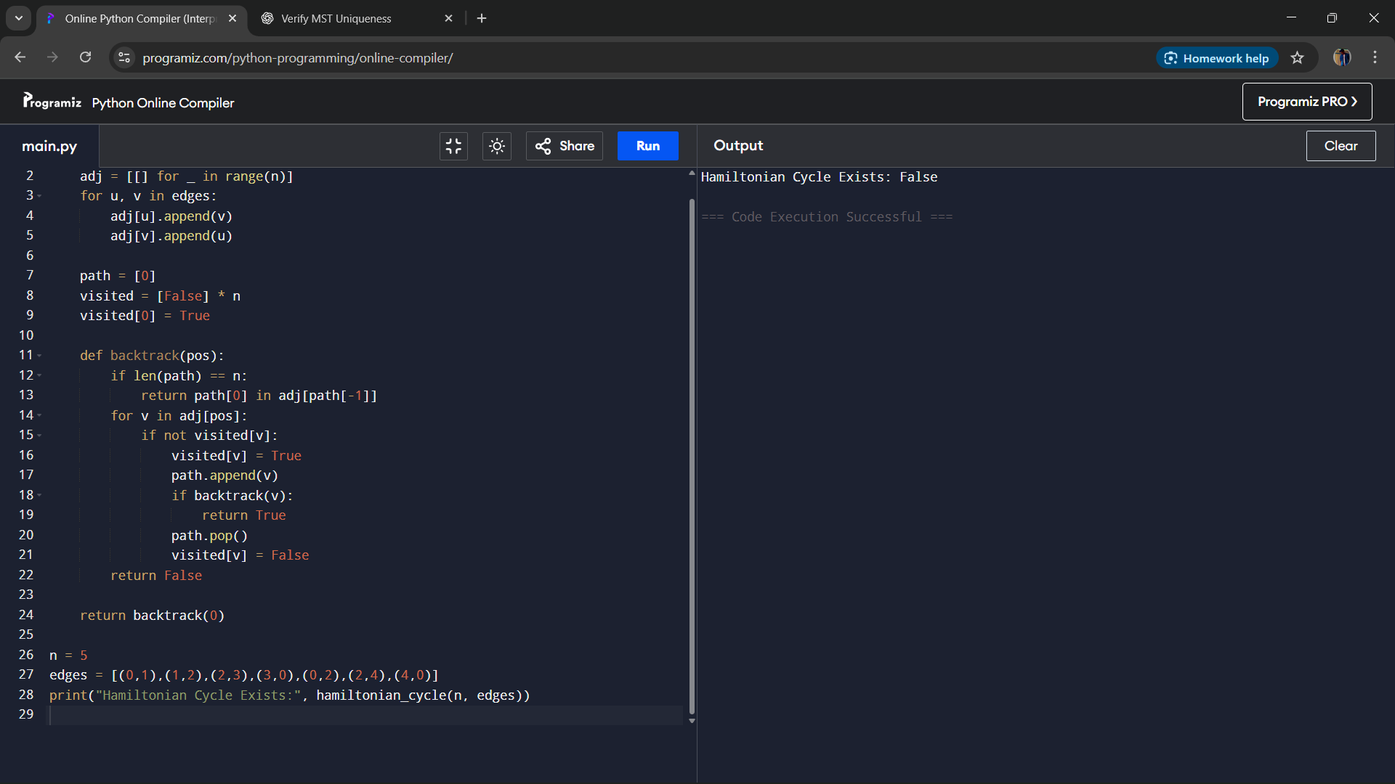
Result
The algorithm successfully determines whether a Hamiltonian cycle exists in an undirected graph and provides one possible cycle if it exists.
Performance Analysis
- Time Complexity: O(n!), since Hamiltonian cycle detection requires checking all permutations in the worst case.
- Space Complexity: O(n) for recursion and path storage.

